1. Given the following set of data:

Weight measurement for 16 small orders of food packets (in gms)

78, 72, 69, 81, 63, 67, 65, 75, 79, 74, 71, 83, 71, 79, 80, 69

1. Create a simple histogram from the above data.
2. Create a horizontal histogram from the above data.
3. Create a step type of histogram from the above data.
4. Create a cumulative histogram from the above data.

Solution –

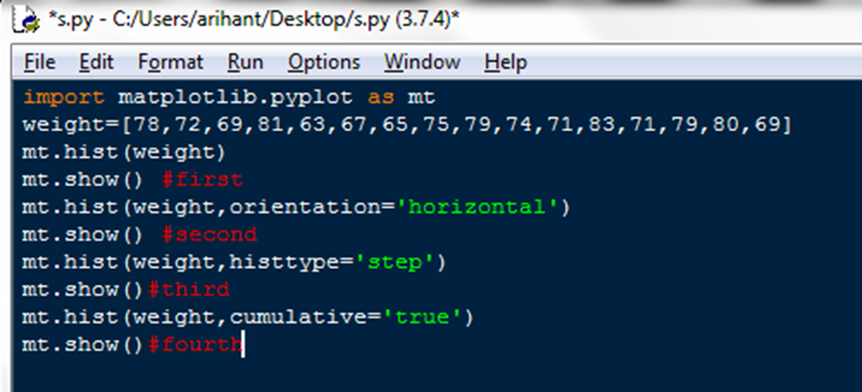

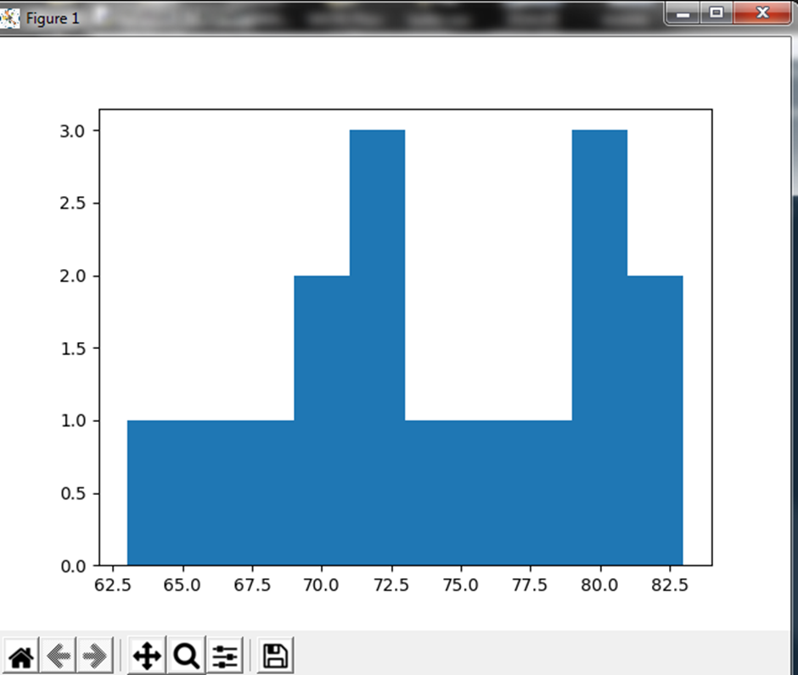

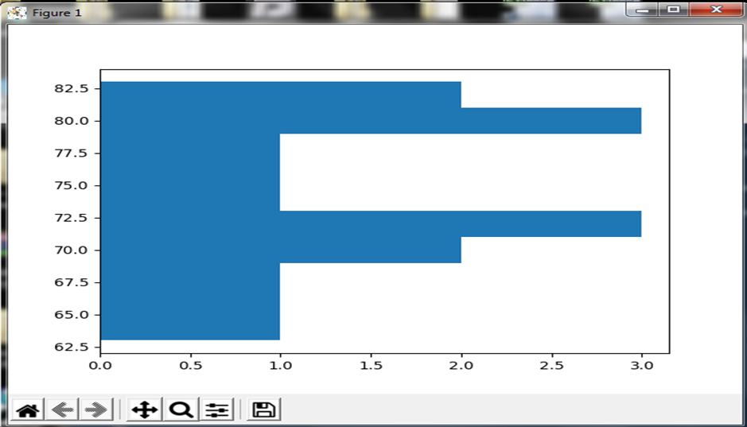

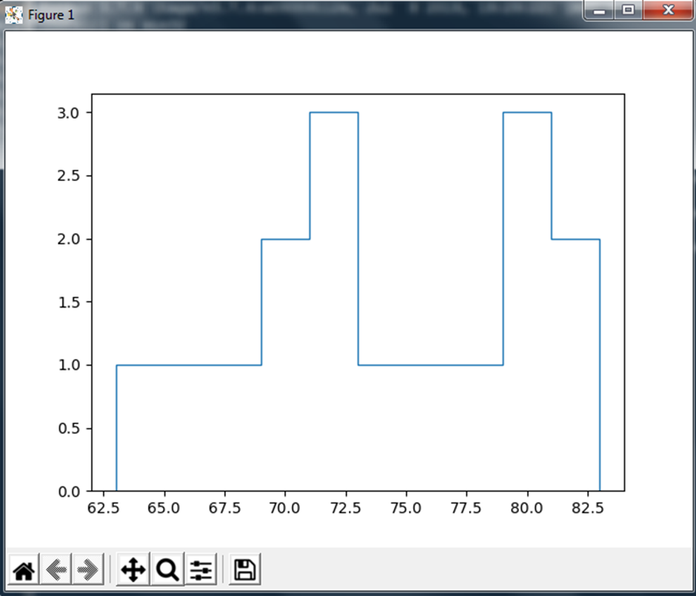

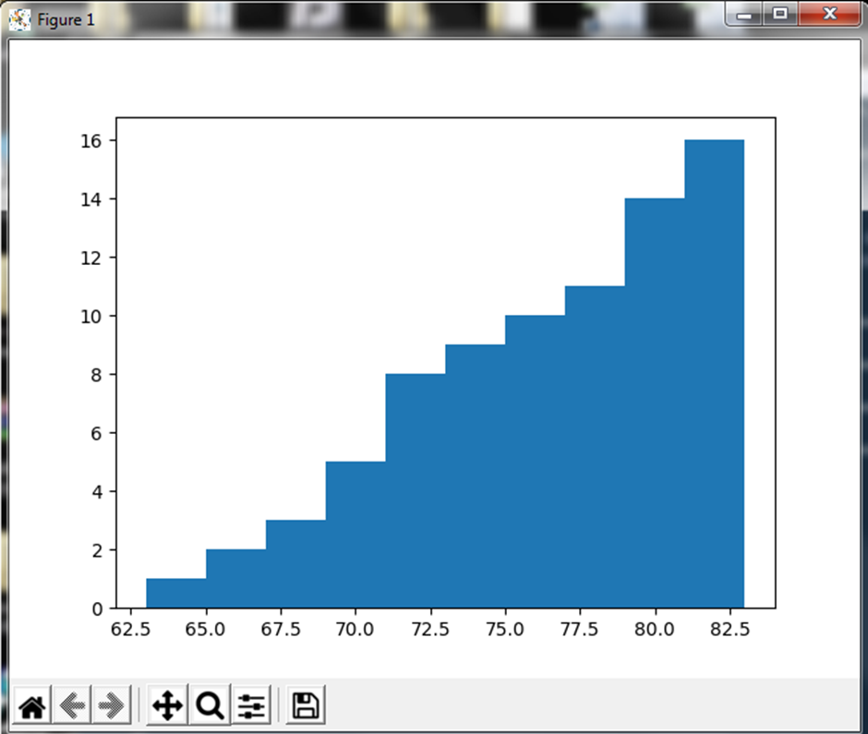

1. The table shows passenger car fuel rates in miles per gallon for several years. Make a LINE GRAPH of the data. During which 2-year period did the fuel rate decrease?

YEAR: 2000 2002 2004 2006

RATE: 21.0 20.7 21.2 21.6

Solution –

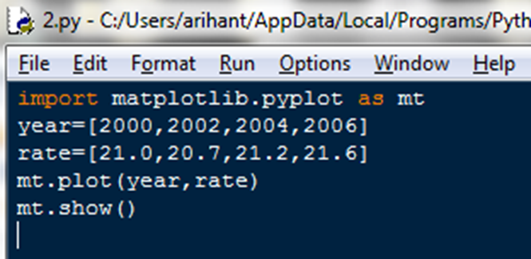

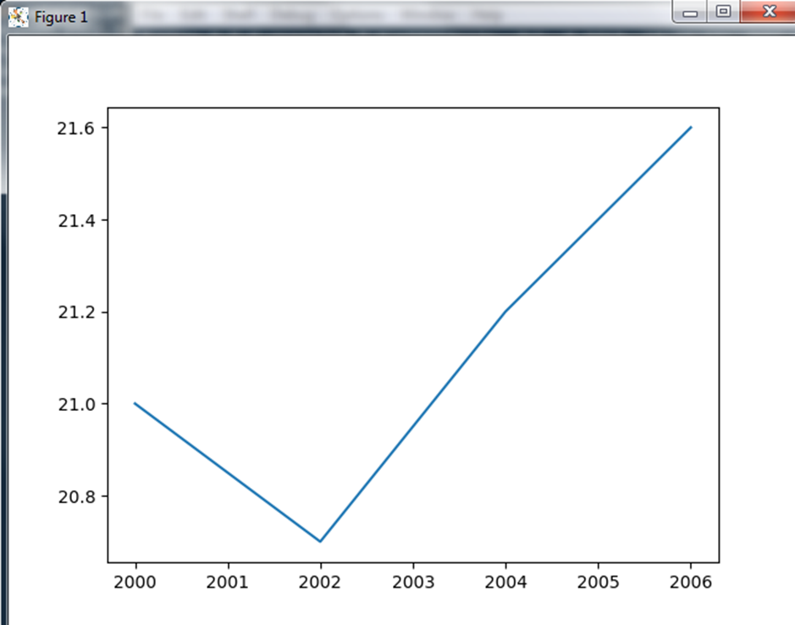

1. Create multiple line charts on common plot where three data ranges are plotted on same chart. The data ranges to be plotted is/are:

Data=[[5.0,25.0,45.0,20.0],[8.0,13.0,29.0,27.0],[9.0,29.0,27.0,39.0]]

Solution –

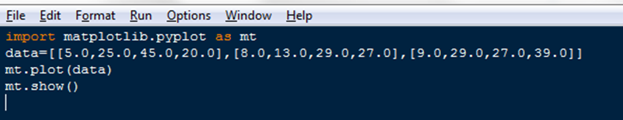

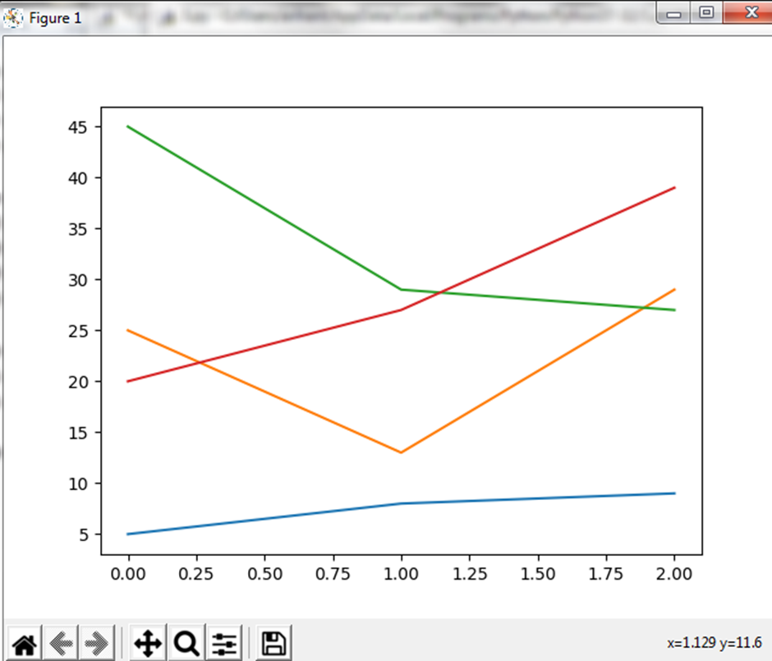

1. *Var* is a list having three lists inside it. It contains summarized data of three different trials conducted by company ABC corp. Create a bar char that plots these three sublists of *Var* in a single chart. Keep the width of each bar as 0.25.

Solution –

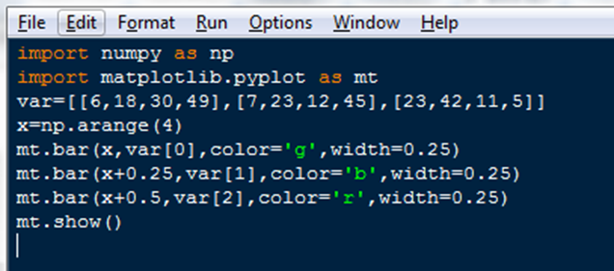

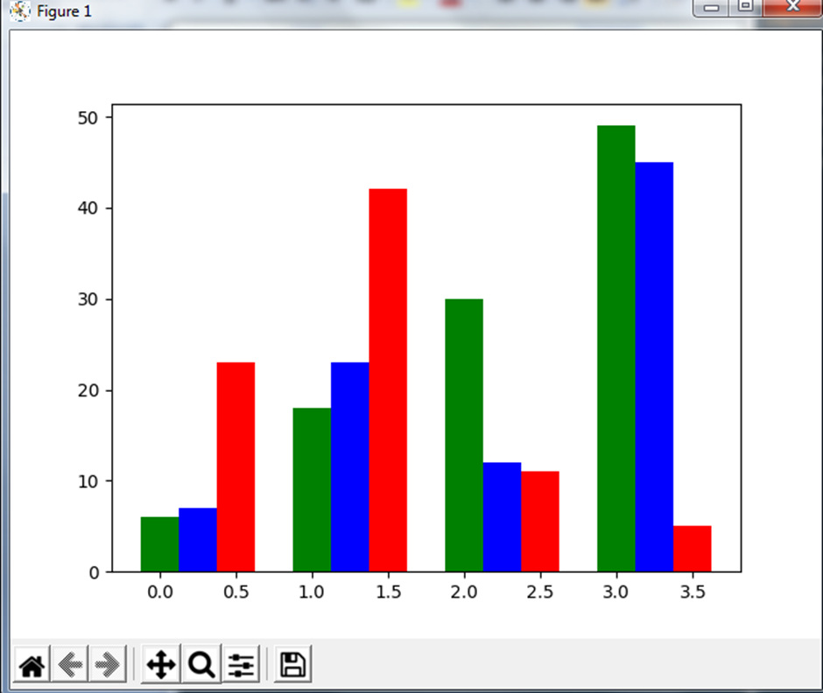

1. Write Python code to create a Series T1 that stores temperatures of seven days in it. Take any random seven temperatures.

•Write a code to change its indexes by ‘Sunday’, ‘Monday’, ….., ‘Saturday’.

•Write a code display the temperatures recorded on first 3 days and last 2 days.

•Write a script to print the average temperature per week and maximum temperature recorded in the week.

•Write a code to check Series contains some NaN values or not.

Solution –

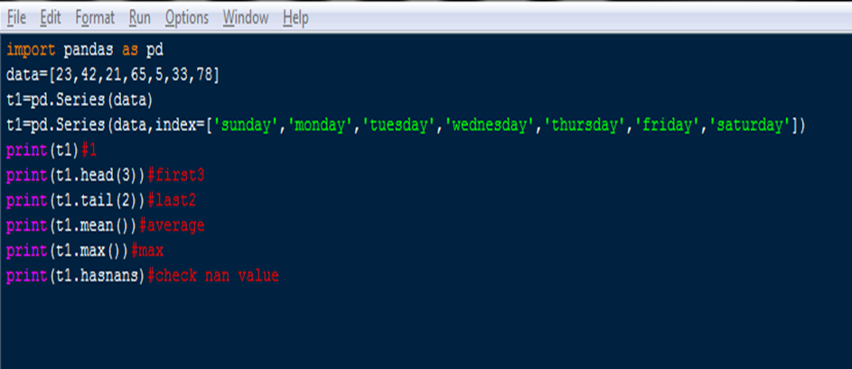

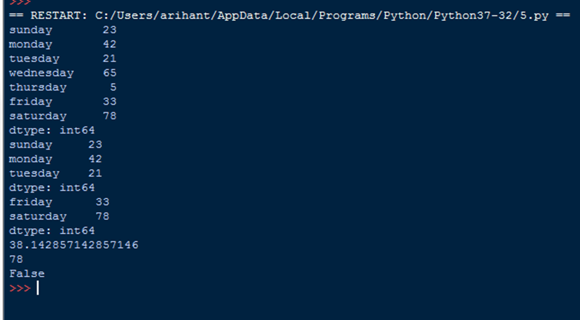

1. In an online contest, 2 player team’s points in 4 rounds are stored in two DataFrames as shown below:

Team1

p1 p2

1 800 560

2 900 450

3 675 545

4 700 490

Team2

p1 p2

1 1500 1300

2 1700 1250

3 1600 1190

4 1300 1500

* 1. Write a program to calculate total points earned by both the teams in each round.
  2. Display how much point difference Team2 has with Team1.
  3. Calculate the average points obtained by each player in each round.
  4. Perform binary operation div() and mul() between two teams.

Solution –

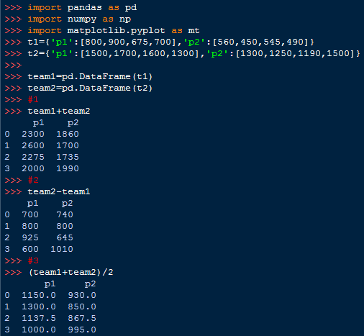

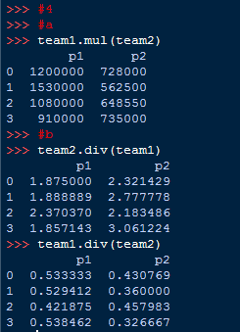

1. Create a DataFrame *df1*as shown below:

yr1 yr2 yr3

Qt1 34500 55500 65500

Qt2 56000 45000 40000

Qt3 47000 65000 57000

Qt4 49000 35000 34000

* 1. Using iterrows( ) to extract data from dataframe row wise.
  2. Using iteritems( ) to extract data from dataframe column wise.

Solution –



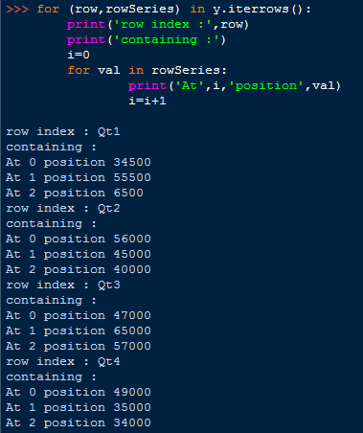

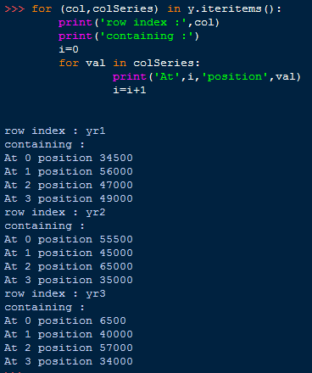

1. Given a DataFrame namely ***Data*** as shown in adjacent figure (fruit names are row labels).

*Color Count Price*

*Apple Red 3 120*

*Apple Green 9 110*

*Pear Red 25 125*

*Pear Green 26 150*

*Lime Green 99 70*

Write code statement to:

1. find all rows with the label “Apple”. Extract all columns.
2. list only the columns Count and Price using loc.
3. list only rows with labels “Apple” and “Pear” using loc.
4. Add a new row at the end of DataFrame.

Solution –

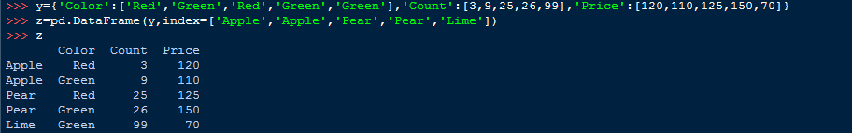

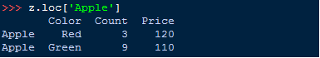

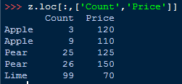

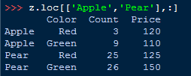

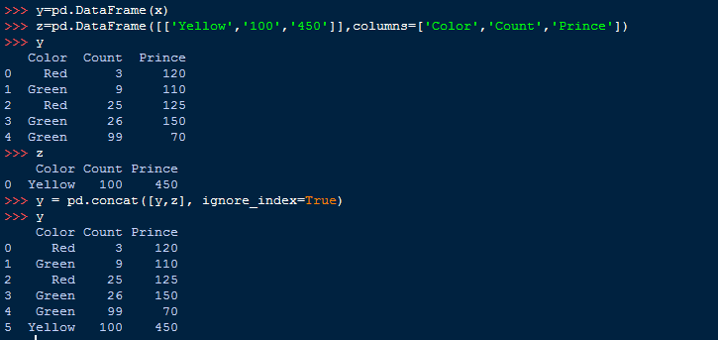

1. Consider the above DataFrame ***Data*** in Question 8. Write code statement to :
2. compute sum of Count and Price column.
3. compute maximum and minimum price.
4. compute average price of last 3 rows.

Solution –

Q9

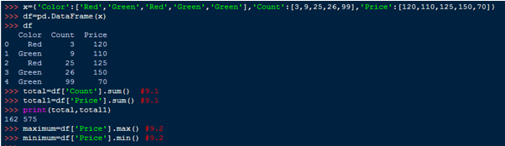



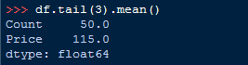

1. Write a Pandas program to add, subtract, multiple and divide two Pandas Series.

Solution –

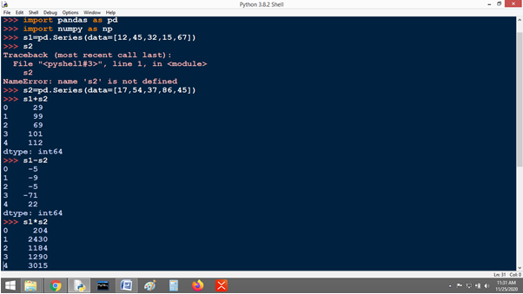

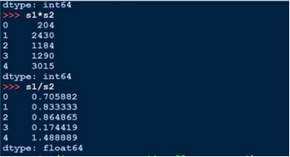

1. Write a program to create a DataFrame to store weight, age and names of 3 people. Print the DataFrame and its transpose.

Solution –

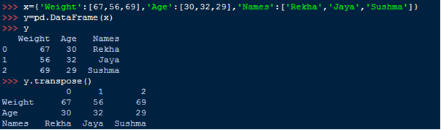

1. Given are two objects, a list object namely lst1 and a series object namely ser1, both are having similar values i.e. 2,4,6,8. Find out the output produced by following statements:

A. print(lst1*2) B. print(ser1*2)

Solution –

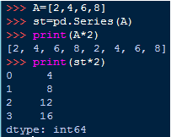

1. Write a program to sort the values of a series object S1 in ascending order of its value and store it into S2 and descending order of its indexes and store in S3.

Solution –

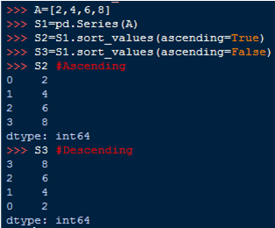

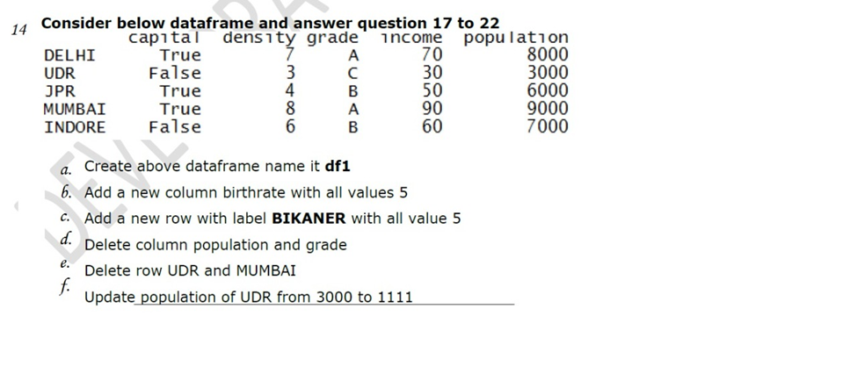

Solution –

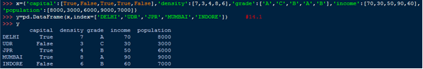

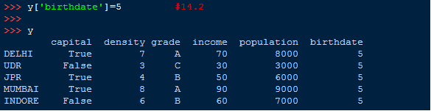

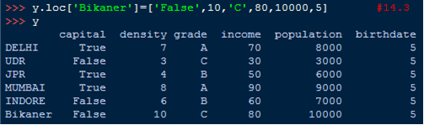

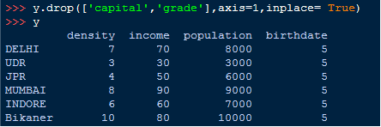

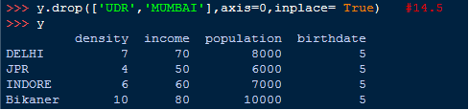

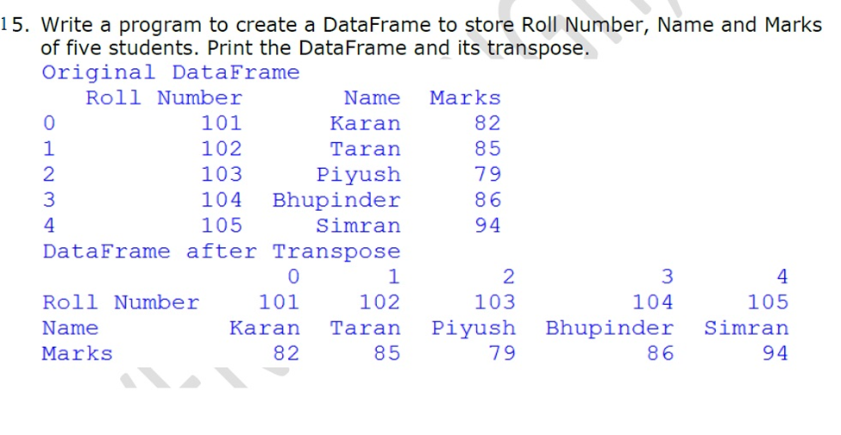

Solution –

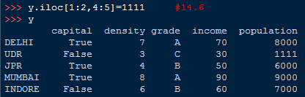

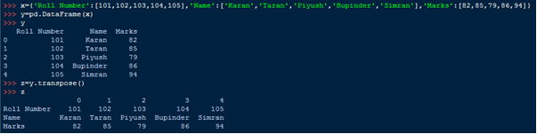

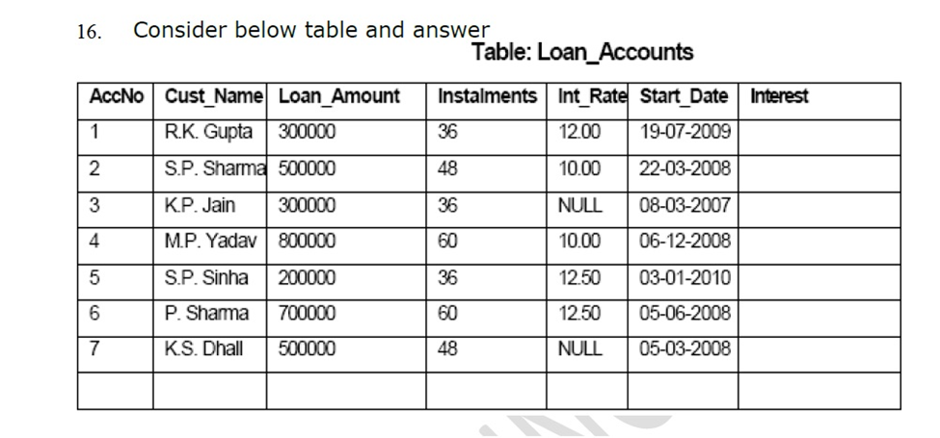

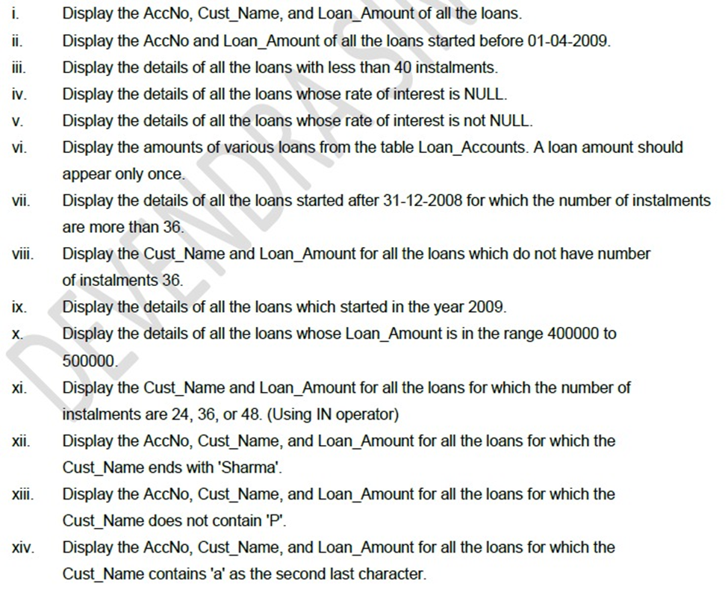

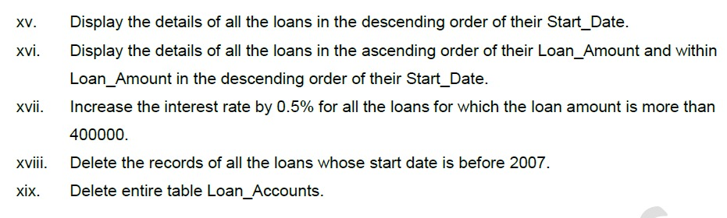

Solution –

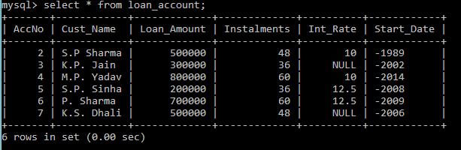

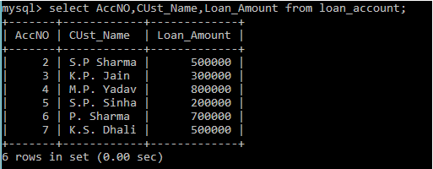

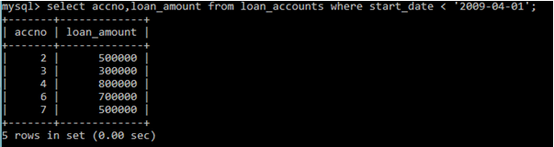

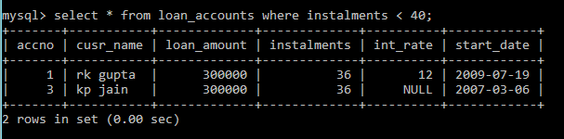

Q16

Q16

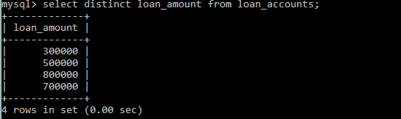

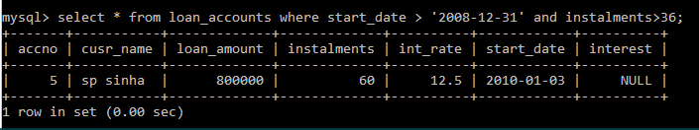

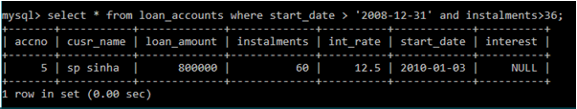

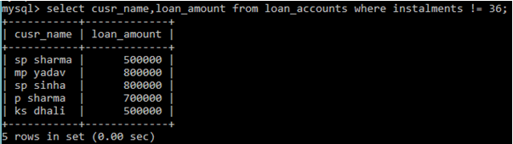

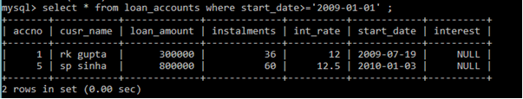

Q16

